---------------------------------------------------------------------------

**Name : Atharva Paliwal**

**Roll No : 40 [5B]**

---------------------------------------------------------------------------

**\*\*\* EXPERIMENT NO: 01 \*\*\***

****************************************************************************

**AIM- Write a Programme to implement transposition and one time pad cipher**

****************************************************************************

**CODE-**

***************************************************************************

**TRANSPOSITION CIPHER**

***************************************************************************

#Atharva Paliwal

def transposition(msg,rows,cols): #Encryption and Decryption Function

k=0 #index of text message

arr = [[0]*cols for j in range(rows)] #matrix initialisation

for i in range(rows):

for j in range(cols):

if k>=len(msg): #if matrix size exceeds length of message

arr[i][j]=' ' #giving spaces

continue

arr[i][j]=msg[k]

k=k+1

print('Matrix :') #printing matrix

for i in range(rows):

print(*arr[i])

newmsg=''

for i in range(cols): #adding message column-wise

for j in range(rows):

newmsg=newmsg+arr[j][i]

return newmsg

msg=input('Enter Your Message : ')

rows, cols =map(int,input('Enter size of row and column : ').split())

encrmsg=transposition (msg,rows,cols)

print('Encrepted Message:',encrmsg)

decrprmsg=transposition (encrmsg,cols,rows)

print('Decrepted Message:',decrprmsg)

***************************************************************************

**OUTPUT-**

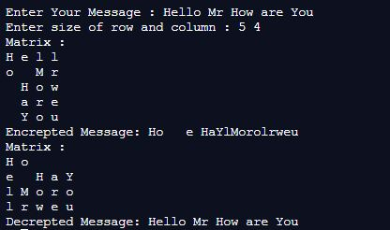

***************************************************************************

***************************************************************************

**ONE-TIME PAD CIPHER**

***************************************************************************

#function for finding index of required text

def find(bit_map,k):

for i in range(len(bit_map)):

if k==bit_map[i]:

return i

#function for encryption

def encrpt(msg,key):

#Initialising a list of alphabets,numbers and space

bit_map=list(chr(i)for i in range(65,91))+list(chr(i)for i in range(97,123))+list(str(i)for i in range(0,10))+[' ']

#increasing key length if key length is smaller

key=key*(len(msg)//len(key)+1)

encr_msg=''

for i in range(len(msg)):

#modulo addition of message with key

encr_msg=encr_msg+

bit_map[(find(bit_map,msg[i])+find(bit_map,key[i]))%63]

return encr_msg

#function for decryption

def decrpt(msg,key):

bit_map=list(chr(i)for i in range(65,91))+list(chr(i)for i in range(97,123))+list(str(i)for i in range(0,10))+[' ']

key=key*(len(msg)//len(key)+1)

decr_msg=''

for i in range(len(msg)):

#subtraction of encrypted msg and key

k=find(bit_map,msg[i])-find(bit_map,key[i])

k=k+[0,63][k<0] #if difference is negative adding 63

decr_msg=decr_msg+bit_map[k]

return decr_msg

#Driver Code

msg=input('Enter Your Message : ')

key=input('Enter the Key : ')

encr_msg=encrpt(msg,key)

print('Cipher Text : ',encr_msg)

decr_msg=decrpt(encr_msg,key)

print('Decrpt Text : ',decr_msg)

***************************************************************************

**OUTPUT-**



